Pegasus Project Horse Leader Training Manual
Volunteers/Volunteer Training/Horse Leader Training Manual

8/14/2019

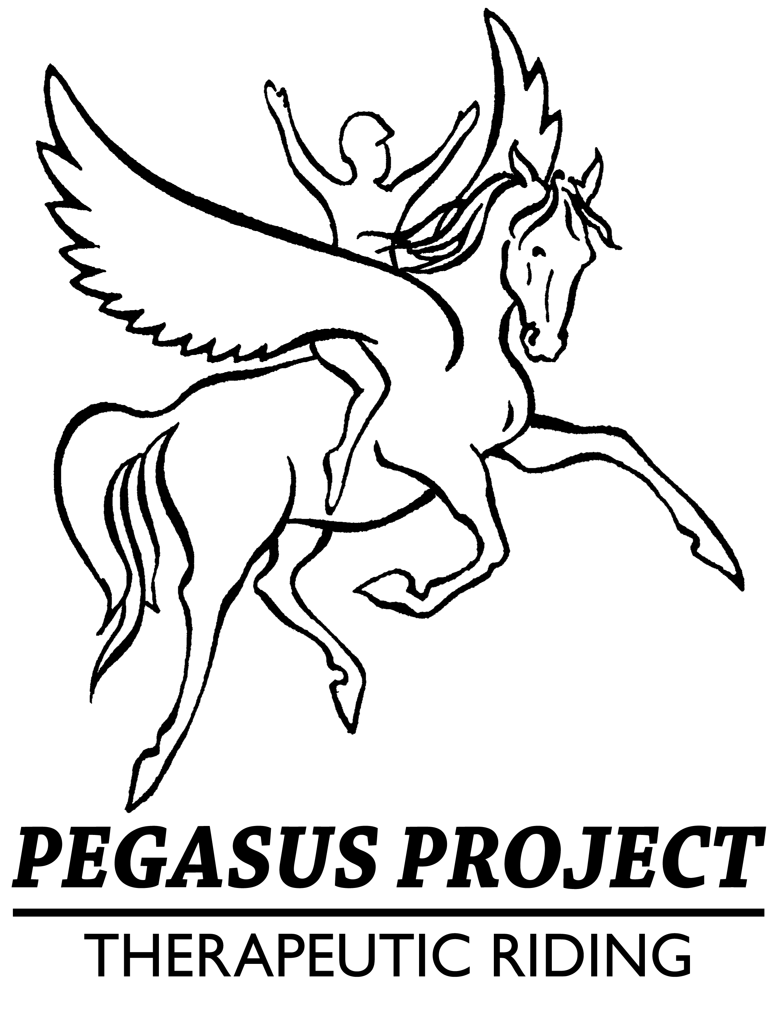

Welcome to Horse Leader Training

Becoming a horse leader is a fun part of volunteering at The Pegasus Project. If you are interested in becoming a horse leader, you must show commitment by having volunteered as a side walker for a minimum of one 8-week session or 16 arena hours. The next step is to read over this manual thoroughly and then attend the next Horse Leader Training.
Horse Leader training consists of a checklist of skills related to horse handling. Once you have mastered this checklist, and have been evaluated by a Pegasus instructor, you will be placed into our system as a Horse Leader.

Horse Leader Rules
- Check the daily schedule before you begin. This will tell you which horses to prepare, what equipment to use, and if there is any rider change.

- Groom and tack the horse; some riders may assist when appropriate. (See tack list or ask instructor).

- Keep noise and tension levels to a minimum in the barn aisle and arena. No yelling, running, or sudden movements around the horses or mounting area. No obscene or discriminatory language.

- Backpacks, purses, or other personal items should be left in your vehicle. Pegasus Project will not be held responsible for loss of personal belongings. Help keep areas clear to avoid tripping or blocking safe passage at all times. Keep aisle-way and tack room clear of unnecessary items.

- No cell phones while horse leading! Leave them in your car or on the volunteer table with the ringer off. This is imperative to keep a safe class environment.

- Volunteers may not bring dogs on the property. Not even in your car; please leave your beloved pets at home. They may scare a horse and cause injury to a rider, volunteer, staff or horse. Our insurance does not cover dogs on the property.

- Gather needed tack and supplies before removing a horse from their stall and taking them into the cross tie area.

- Be alert and attentive to the horse you are working with and the other horses around you. Watch their body language for any signs of discomfort or distress.

- Please do not go behind or under (neck or belly) the horse at any time.

- No unnecessary touching of the horses will be allowed during “work” hours– including petting of the head.

- While riders are mounted, please do not open the gates to bring your horse in or out of the arena until asking the instructor for permission. The instructor must have all horses at a halt before the gates can be opened.

- Always lead the horse so that his head is near your shoulder. Hold the rope with two hands, one hand is loosely holding the rope with enough slack to leave a “smile” in the rope, the other hand is holding the excess lead, accordion style. NEVER wrap the lead rope around your hand.

- Talk to your horse; our horses know verbal commands , and the riders will use “Walk On,” “Trot” and “Whoa” to start and stop the horse. Allow the rider to do as much as possible once they are on the horse!

- All corrective measures (discipline) will be done by an instructor or other staff personnel. If your horse is “misbehaving,” please alert an instructor or other staff person ASAP and they will handle the issue.

Cross Tie Area Rules

2 person limit (+instructor as needed) in the cross-ties.

Never attach a cross-tie to the bridle of the horse. (This includes sidepulls and bitless bridles).
- Horses should never be out of line of sight while in cross ties. Gather all tack and supplies needed BEFORE bringing horse out of stall.
- While horses are in the cross-ties, additional people shall remain behind the yellow line and allow Horse Leaders to work directly with riders to tack and untack. Side walkers are there to help riders put away tack; Horse Leaders stay with the horse.
- In the event the rider does not have side walkers, the Horse Leader shall help the rider put away tack as long as staff or trained horse leader is watching the horse.
- Always maintain contact with your horse until they are secured with both cross ties; leave the lead rope on and put it over the horse’s neck.

- Always use a lead rope attached to the halter when leading the horses. Never lead them by the halter even for short distances.

- Always use a bit clip to attach the lead rope to the bit or rings of the sidepull or bitless bridle. Never attach the lead rope directly to a bit or bridle.

Mounting & Dismounting:

Mounting

At the block
- DO NOT EVER ATTEMPT TO MOUNT OR TO DISMOUNT THE RIDER BY YOURSELF, always listen for instructor direction for each rider during mount/dismount.
- The Instructor will always initiate each rider’s mount/dismount.
- Position yourself in the halt position in front of the horse (facing the horse) and slightly to one side, and keep the horse steady while the rider mounts.
- When cued by instructor, proceed out of mounting area, along the rail for 3-5 strides (or the first window) before stopping for a tack check.

At the Ramp
- Wait for Instructor to perform a tack check.
- Do not load the horse in the Ramp until you have been asked to by the Instructor.
- When loading the horse, ask the horse to walk 1 step at a time into the ramp
- Stand 45 degrees in front of the horse while rider is mounting and walk one step at a time when exiting the ramp until volunteers are safely off of the ramp.
- Halt and move into the correct leading position before proceeding.

Dismounting

In the Arena
- The horses will line up in arena. Be sure to watch your safety spacing (at least 1 horse length 360⁰).
- The Instructor will provide direction for dismounting each rider. When appropriate, the rider will help put their stirrups up and lead their horse out of the arena.
- When ready, horses exit the arena through the A gate, one at a time.
- The horse is taken back to the cross-ties, un-tacked, groomed and returned to the stall. Do not pick feet/hooves unless instructed by the lesson instructor.

- Use the correct “Safety Spacing” of at least one horse length whenever you are leading a horse whether you have a rider mounted or not.

- When saddling the horses, slowly tighten the cinch, just enough so the saddle won’t fall off. Do not over tighten the cinch, the instructor will check and tighten the cinch before & after mounting.

What to do in an emergency or ‘Unusual’ circumstance

- In the event of a loose horse:
- If a horse gets loose in the arena or on the sensory trail, please stay calm and halt.
- Do not leave your horse to catch loose horse
- Listen to the Instructor for further guidance for the specific situation

- In Case of a Seizure of Participant:
- Halt
- Horse Leader’s priority is to focus on the horse and use all the techniques in this Manual and the training to keep the horse calm and relaxed.

- In the Event Rider Falls off Horse
- Stay calm
- Say “Instructor” loud enough for people to hear
- Horse leader leads horse far away from rider
- Other horse leaders shall lead horses and riders away and perform halts.
- Instructor will assess the fallen rider and may have side walkers assist.

- Fire or Earth Quake
- Focus on your horse and keep your horse as calm as you can.
- Listen for instructor prompts for emergency dismount.
- Do your best to move horse away from the rider(s).
- After people have exited the arena proceed to the designated meeting area.

These rules are set in place to physically and emotionally protect our horses’ well-being and to optimize their involvement in our program. Our horses are vital to the success of our clients. These rules are set in place to create a safe environment for everyone involved, and to ensure our horses’ physical, mental and emotional health as a part of our team, as well as insure the safety of our riders and volunteers, including you.

Arena Assistant Position
Once a volunteer has gone through Horse Leader training, they are eligible to become an Arena Assistant under the Volunteer Coordinator’s approval.
- Assist the flow of our riding program classes by coordinating activities in the barn before, during and after classes.
- Understand the needs of the barn, horses, and class structure.
- Review daily volunteer schedule
- Prepare for classes – groom boxes and tack laid out for each class
- Greet volunteers and assign tasks; delegate tasks as needed
- Maintain a positive and helpful attitude
- Assist in classes as needed
- Assist volunteers with horses that are finished with classes – untack and return horses to correct stalls.
- Assure that tack is put away properly.
- Assist with barn clean up if time allows
- Communicate with class instructor to see what, if anything, needs to be done

